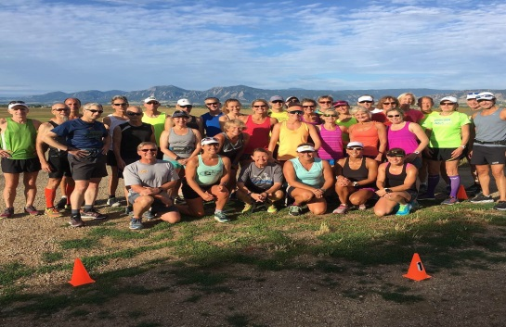
Training Details
- 16 Week Training Program…4 weeks Base and 12 weeks of Group Workouts (Feb 4th thru May 27th)
- Training begins the week of Feb 4th (schedule posted on front page of website)
- Boston Crew will SKIP Base and keep training as Normal
- FIRST MEETING – Wed Feb 6th
- There will be 2 Training Groups BASED on MEETING times: morning and evening with all abilities welcome
  - evening meets Wed @ 5:30 pm and Sat @ 7:30 am
  - morning meets Wed @ 6:30 am and Sat @ 7:30 am
- Train with other Boulder Strider Members at your goal pace in a non-intimidating fun atmosphere
- Bring a NEW Friend to Join Boulder Striders and you BOTH get $25 off your registration fee
Boulder Striders’ Program Rates
Early Bird Special Pay by Feb 9th (NO Exceptions) | $300  $275 | Twice/week - 4 weeks base / 12 weeks of twice a week training  Once/week – 4 weeks base/ 12 weeks of once a week training
Regular Price  Starts Feb 10th | $325  $300 | Twice/week - 4 weeks base / 12 weeks of twice a week training  Once/week – 4 weeks base/ 12 weeks of once a week training
MAKE CHECKS PAYABLE TO: BOULDER STRIDERS
OR CREDIT CARD...ADD $12 TO THE PROGRAM RATE
Please Print & Mail Registration (postmarked Feb 9th to get early bird…Please NO exceptions) to:
Boulder Striders, 4162 Saint Croix St, Boulder, CO 80301
2019 Spring Registration Form
Last Name |  |  |  |  | First Name
Address
City |  |  |  | State |  |  |  |  |  | Zip
DOB |  |  | Email
Day Phone
 | Evening: Wed/Sat (5:30 pm /7:30 am ) |  |  |  |  |  | Morning: Wed/Sat (6:30 am / 7:30 am )

By signing this Registration Form, I do not hold Colleen De Reuck, Boulder Striders or any of the Coaches liable for injury to myself during the 16 week training. One Form per Member…Photocopies are good.

Signature: __________________________________________

